The MINERvA Model

Objective: to construct a 3-dimensional, simplified model of the MINERvA apparatus for classroom reference and discussion.

Materials: 20 - paper card-stock hexagons (Optional: use 3 different colors of card stock, having a combination of 10, 5, 5 for the hexagons)
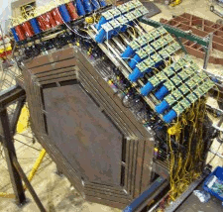
Hole puncher
Scissors
3-different colored pipe cleaner
8 inch dowel
Glue
Tiny puffy-balls

Procedure:
- Cut out the hexagons on the outer line only

- Arrange the hexagons with the following repeating pattern:
Inner Strips upright (center)
Inner Strips 60º right of center

Inner Strips upright (center)
Inner Strips 60º left of center

- Glue the combination of 2 hexagons together. The grouping of 2 hexagon panels represents a module.

- At the bottom, center of the hexagon place one hole-punch
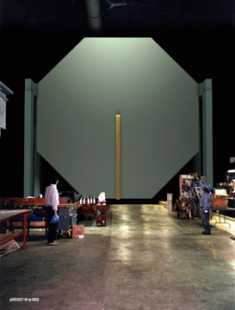
- Repeat the process, making a total of 10 modules.

- Cut out the MINOS detector and punch a hole at the center of the bottom

- Position the 10 modules on the dowel, folding (or cutting) the bottom pointed-edge of each module into a flat plane. Leave a gap between every module (for interior viewing). Place the MINOS detector at the end, after the 10th module.
If needed, glue the modules in place after the model is completely constructed.

- Poke a colored pipe-cleaner through the center of the first few modules to represent the path of the incoming neutrino. The incoming neutrino will strike a neutron (puffy ball) that is glued to the front side of the module where the neutrino path ends.

- From the neutron, on the opposite side of the same module, glue a colored fuzzy ball to represent the proton. Use a colored pipe-cleaner to represent the path of the outgoing proton. The pipe-cleaner should only travel through a few modules

- From the neutron, on the opposite side of the same module, glue a colored fuzzy ball to represent the muon. Use a colored pipe-cleaner to represent the path of the outgoing muon. You will cut 2 pipe-cleaners of this color, one long and one short.
- To demonstrate the possibility of muon decay, the short pipe-cleaner should travel to the 8th module. On the 10th module glue a puffy ball to represent the electron produced in the decay.
- To demonstrate the high energy muon event, use the 2nd, longer, pipe-cleaner (same color as the previous step). This pipe-cleaner will represent the path of the muon as it leaves the active target area and reaches MINOS.

NOTE: The neutron will not produce both types of muons (one that decays and one that travels through the active target area) at the same time. These would be 2 separate events; representing 2 possible outcomes for the muon based on its energy level.

Diagram:

e⁻
nº
p⁺
µ⁻
M
I
N
O
S

Analysis Questions:

- Write the reaction for a neutrino striking a neutron:

- Explain the significance of each module consisting of 2 panels in different planes?
__________________________________________________________________
__________________________________________________________________
__________________________________________________________________
__________________________________________________________________

- What is the purpose of the MINOS detector at the end the MINERvA experiment?

____________________________________________________________________
____________________________________________________________________
____________________________________________________________________
____________________________________________________________________

1 copy

MINOS

5 copies

3 copies (1 hexagon will not be used)

3 copies (1 hexagon will not be used)

